**Project name:**

**Job Application Tracking System - (Developer) - (Shortterm)**

**INTRODUCTION:**

Create a CRM Application which helps the applicant to track the No. of jobs he applied and helps him to find the job posted by the various recruiters, find the best attributes to be involved to run the process in a smooth way and easily to track.

**Creating A Salesforce Developer Org:**

A Developer org has all the features and licenses you need to get started with Salesforce.

1.Go to developer.salesforce.com

2.Click on signup.

3.On the sign up form, enter the following details

a. First name & Last name -KATAKAM HARSHAVARDHAN

b. Email [–harshavardhan200402@gmail.com](mailto:–harshavardhan200402@gmail.com)

c. Role – Developer

d. Company – GAYATRI DEGREE COLLEGE – TIRUPATI

e. Country – India

f. Postal code – 517501

g. Username – harsha@gdctirupati.com

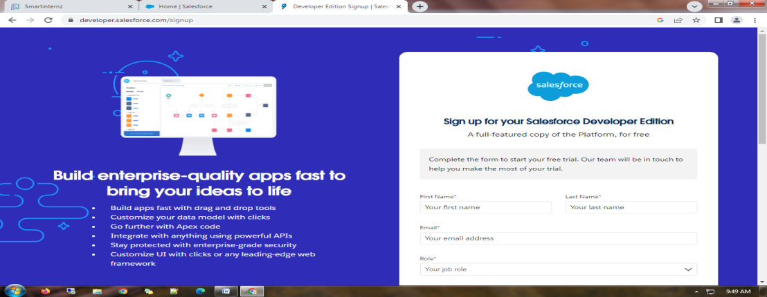

4.Click sign me up, after a few min you will reserve a mail salesforce org and by using the verify account link you can create your new password.

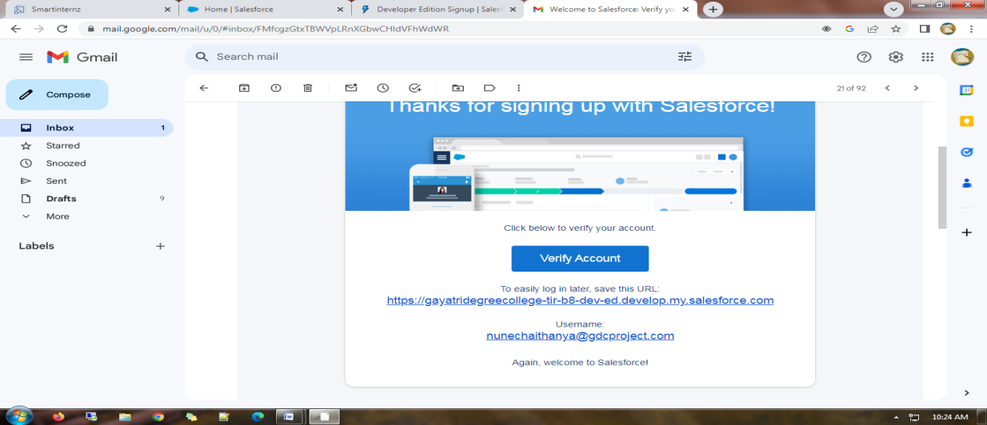

4. Click save.

5.Search login.salesforce.com

6.By using username and password you can into the Salesforce org.

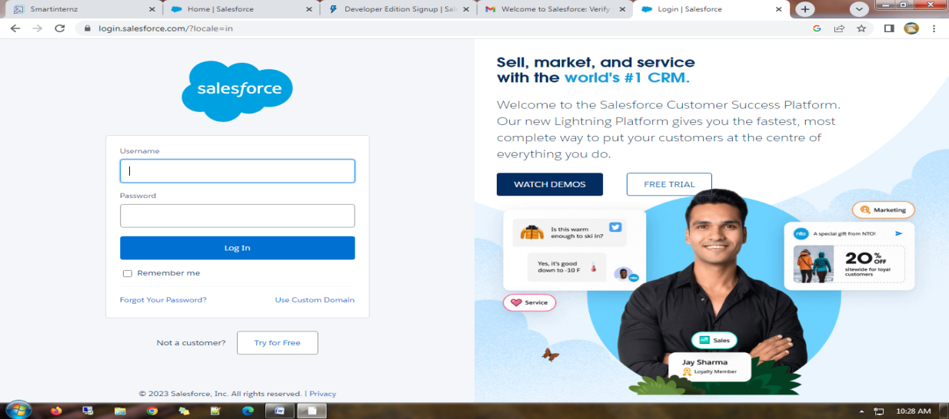

The home page will appear as below.

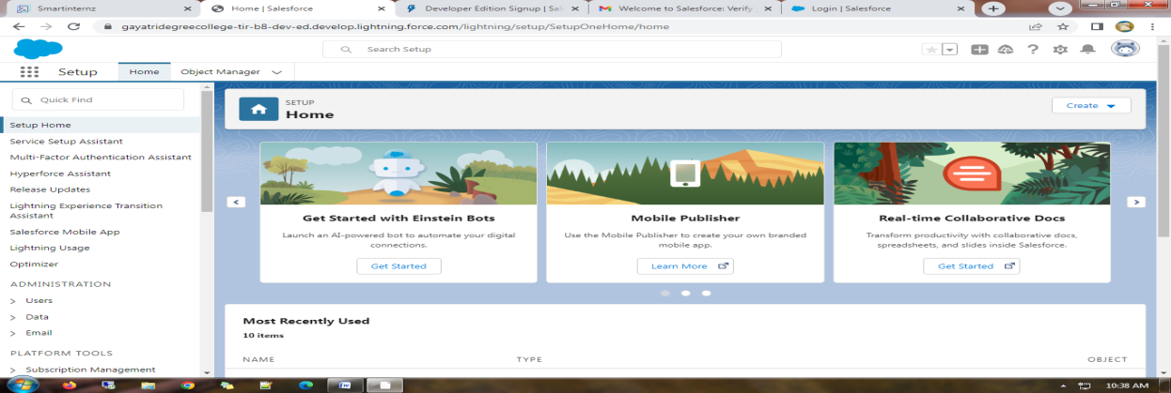

**Milestone 2:**

**Create A Custom Object For Recruiter**

Create a custom object for Recruiter:

To create a custom object, follow these steps:

1. From setup click on object manager.

2. Click create, select custom object.

3. Fill in the label as " Recruiter ".

4. Fill in the plural label as " Recruiters".

5. Record name: " Recruiter Name"

6. Select the data type as "Text".

7. In the Optional Features section, select Allow Reports and Track Field History.

8. In the Deployment Status section, ensure Deployed is selected.

9. In the Search Status section, select Allow Search.

10. In the Object Creation Options section, select Add Notes and Attachments related list to default page layout.

11. Leave everything else as is, and click Save.

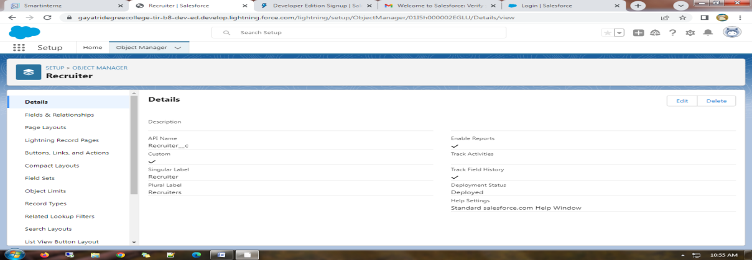

**Creation Of Jobs Object:**

Click on the gear icon and then select Setup.

1. Click on the object manager tab just beside the home tab.

2. After the above steps, have a look on the extreme right you will find a Create Dropdown click on that and select Custom Object.

3. On the Custom Object Definition page, create the object as follows:

* Label: Job
* Plural Label: Jobs
* Record Name: Job Name
* Select the data type as "Text".
* Check the Allow Reports checkbox
* Check the Allow Search checkbox
* In the Object Creation Options section, select Add Notes and Attachments related list to default page layout
* Click Save.

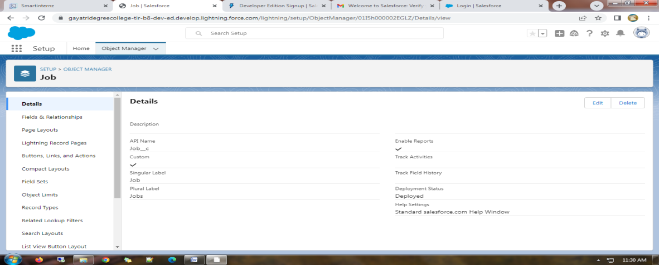

**Creation Of Candidate Object :**

1. Click on the gear icon and then select Setup.
2. Click on the object manager tab just beside the home tab.
3. After the above steps, have a look on the extreme right you will find a Create Dropdown click on that and select Custom Object.
4. On the Custom Object Definition page, create the object as follows:

* Label: Candidate
* Plural Label: Candidates
* Record Name: Candidates Name
* Select the data type as "Text".
* Check the Allow Reports checkbox.
* Check the Allow Search checkbox.
* In the Object Creation Options section, select Add Notes and Attachments related list to default page layout.
* Click Save

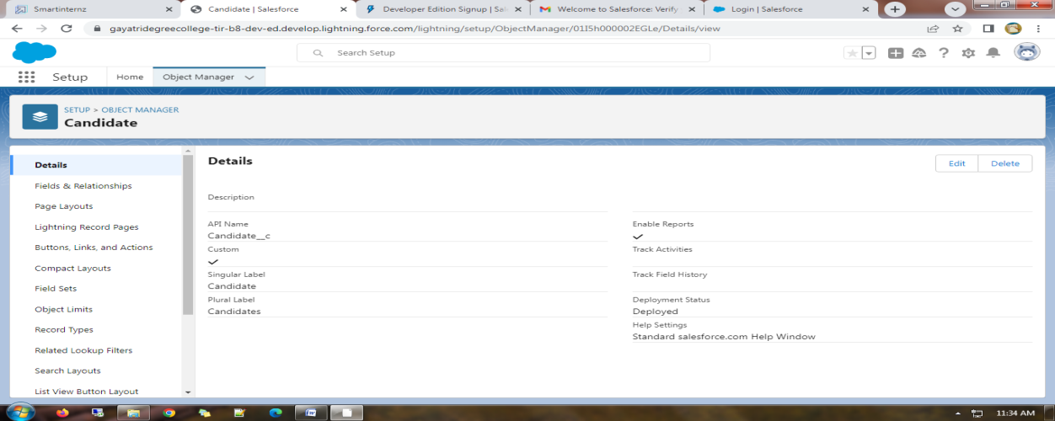

**Creation Of Job Application Object :**

1. Click on the gear icon and then select Setup.
2. Click on the object manager tab just beside the home tab.
3. After the above steps, have a look on the extreme right you will find a Create Dropdown click on that and select Custom Object.
4. On the Custom Object Definition page, create the object as follows:

* Label: Job Application
* Plural Label: Job Applications
* Record Name: Job Application Number
* Select the data type as "Auto Number".
* Under display format enter "JP-{0000}"
* Enter starting number as 1
* Check the Allow Reports checkbox.
* Check the Allow Search checkbox.
* In the Object Creation Options section, select Add Notes and Attachments related list to default page layout.
* Click save.

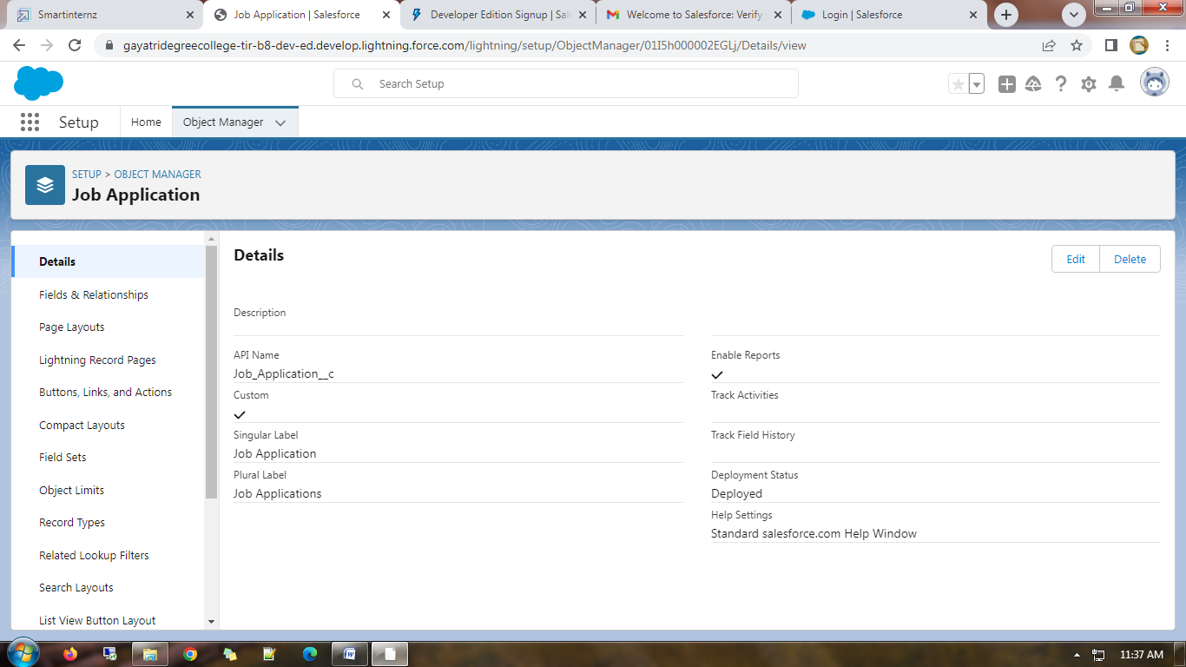

**Milestone – 3:**

**Tab**

**Creation Of Recruiter Tab:**

Now create a custom tab.

1.Click on Home tab, enter Tabs in Quick Find and select Tab.

2.Under custom object tabs, click New.

3.For Object, select Recruiter.

4.For Tab Style, select any icon.

5.Leave all defaults as is. Click Next, Next, and Save.

**Creation Of Job Tab:**

Now create a custom tab.

1. Click on Home tab, enter Tabs in Quick Find and select Tabs.

2. Under custom object tabs, click New.

3. For Object, select Job.

4. For Tab Style, select any icon.

5. Leave all defaults as is. Click Next, Next, and Save.

**Creation Of Candidate Tab:**

1.Now create a custom tab.

2.Click on Home tab, enter Tabs in Quick Find and select Tabs.

3.Under custom object tabs, click New.

4.For Object, select Candidate.

5.For Tab Style, select any icon.

6.Leave all defaults as is. Click Next, Next, and Save.

**Creation Of Job Application Tab:**

Now create a custom tab.

1.Click on Home tab, enter Tabs in Quick Find and select Tabs.

2.Under custom object tabs, click New.

3.For Object, select Job Application.

4.For Tab Style, select any icon.

5.Leave all defaults as is. Click Next, Next, and Save**.**

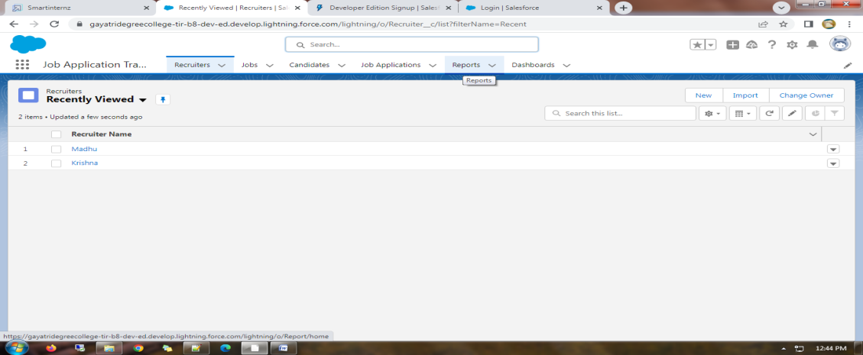

**Milestone – 4:**

**Lightning App**

**Create The Job Application Tracking App**

1. From Setup, enter App Manager in the Quick Find and select App Manager.
2. Click New Lightning App. Job Application Tracking as the App Name, then click Next
3. Under App Options, leave the default selections and click Next.
4. Under Utility Items, leave as is and click Next.
5. From Available Items, select Recruiters, Jobs,Candidates,Job Application Reports,and Dashboards and move them to Selected Items. Click Next.
6. From Available Profiles, select System Administrator and move it to Selected Profiles.Click Save & Finish.
7. To verify your changes, click the App Launcher, type Job Application and select the Job Application app.
8. Note:
   * App Launcher-Displays available apps.
   * App Name-Displays the current selected app.
   * Navigation menu-Displays the tabs available inside the app.

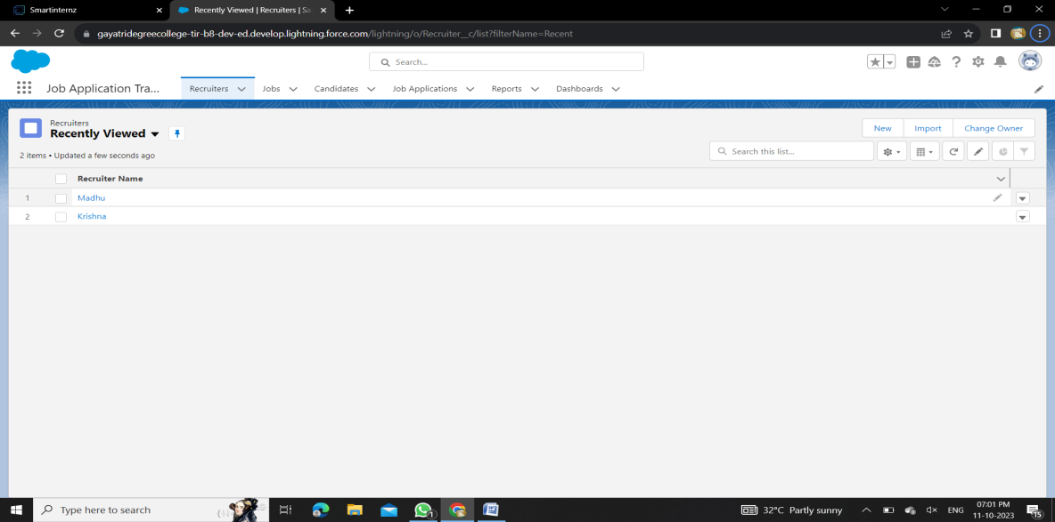

**Milestone – 5**:

**Fields And Relationship**

**Creation Of Fields For The Recruiter Objects**

1. click the gear icon and select Setup. This launches Setup in a new tab.
2. Click the Object Manager tab next to Home.
3. Select Recruiter.
4. Select Fields & Relationships from the left navigation, and click New
5. From the sidebar, click Fields & Relationships. Notice that there are already some fields there. Those are the standard fields.
6. Click New to create a custom field. Tip: Before creating a new field, do a quick search to make sure a similar one doesn’t already exist.
7. Choose the data type as Auto number, click next.
8. Enter field label(Recruiter Number), Display formate RN-{0000} Starting number(1) and click next
9. Next,Next and Click save.
10. Now let's create the other fields follow above Activity1 steps 1 to 4 and we must choose the data types of the fields carefully
    1. Select the Text as the Data Type, then click Next. For Field Label, Job Title. Enter Length (20) Click Next, Next, then Save & New.
11. Select the Email as the Data Type, then click Next. For Field Label, Email.
12. Click Next, Next, then Save & New.
13. Select the phone as the Data Type, then click Next. For Field Label, Phone.
14. Click Next, Next, then Save & New.

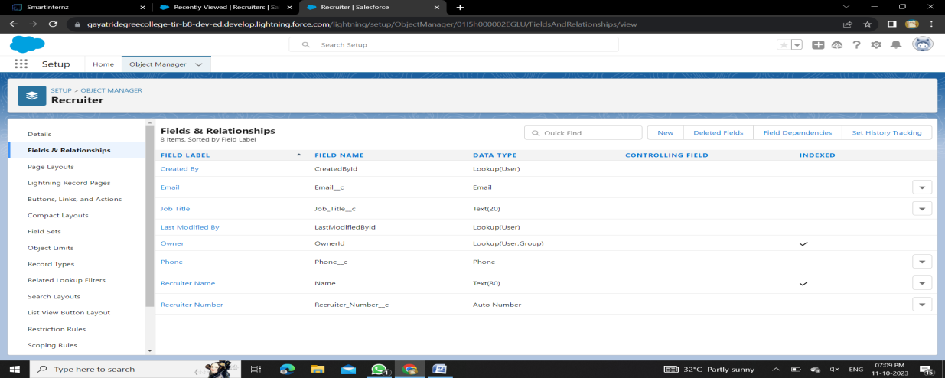

**Creation Of Fields For The Job Objects**

**Follow the above steps from 1 to 4 of activity 1**

1.Select the Auto number as the Data Type, then click Next.

For Field Label, enter Job Application Id., Display format (J-{000}) starting number (001) Click Next, Next, then Save & New

2.Select the Text area as the Data Type, then click Next. For Field Label, Description.

Click Next, Next, then Save & New.

3.Select the Text as the Data Type, then click Next. For Field Label, enter Location, and length (20) Click Next, Next, then Save & New

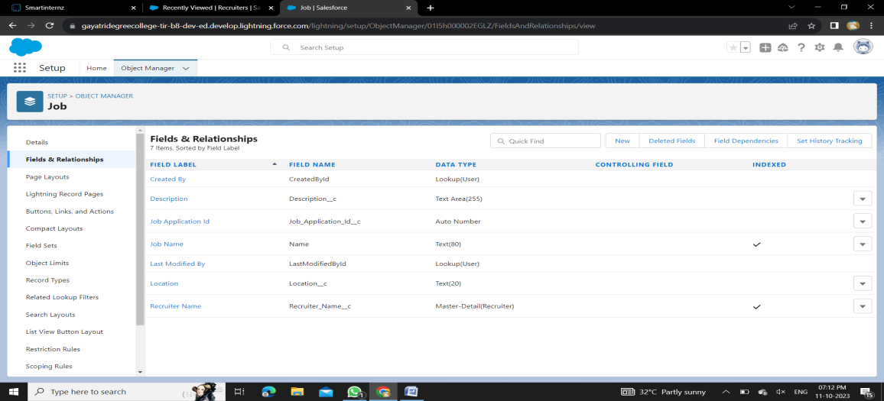

**Creation Of Master-Detail Relationship For Job Object**

1.From Setup, go to Object Manager

2.On the sidebar, click Fields & Relationships.

3.Click New.

4.Choose Master-detail Relationship and click Next

5.Choose the related object(Recruiter) and select that object.

6.Enter the label name(Recruiter Name)

7.Click Next, Next, and Save

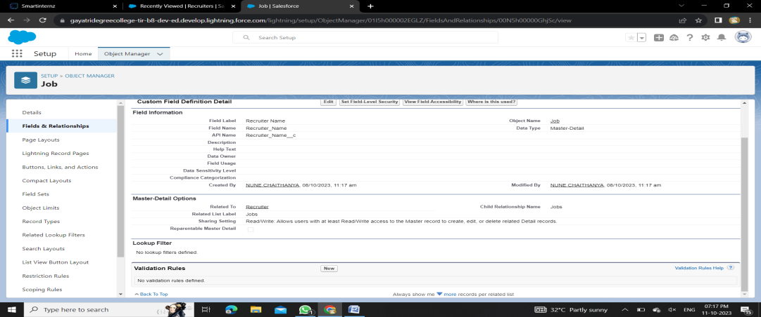

**Creation Of Fields For The Candidate Object**

1.Select the Text area as the Data Type, then click Next. For Field Label, Address,

Click Next, Next, then Save & New.

2.Select the Email as the Data Type, then click Next. For Field Label, enter Email.

Click Next, Next, then Save & New.

3.Select the Phone as the Data Type, then click Next. For Field Label, enter Phone.

Click Next, Next, then Save & New

4.Select Picklist as the Data Type and click Next. For Field Label enter Education.

Select Enter values, with each value separated by a new line and enter these values: Graduation ,

Post-Graduation. Click Next, Next, then Save & New.

5.Select the Text area as the Data Type, then click Next. For Field Label, enter Skill Set.

Click Next, Next, then Save & New

**Create Picklist Fields On Candidate Object**

1. Click on the gear icon and then select Setup.
2. Click on the object manager tab just beside the home tab.
3. After the above steps, Select candidate Object
4. Now Select Fields and relationships from setup menu of the candidate object.
5. Click new and select Picklist fields ????next and enter label name(State) and select enter values option

(Rajasthan, UP, MP, Punjab), next, next and Save.

Follow same above steps for create city and Education Picklist fields with their values.

1.Select Picklist as the Data Type and click Next. For Field Label name City

And Select Enter values, with each value separated by a new line and enter these values

(Jaipur, Jalandhar, Lucknow, Bhopal), next, next and Save.

2.Select Picklist as the Data Type and click Next. For Field Label enter Education.

Select Enter values, with each value separated by a new line and enter these values: Graduation, Post-Graduation. Click Next, Next, then Save & New

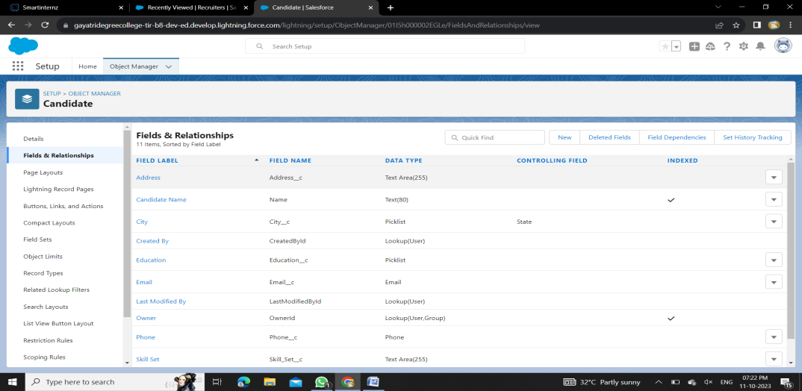

**Create Field Dependency (On Candidate Object)**

Create a dependency between these two picklists, so that when a state is selected, only respective Values are available.

The below steps will assist you in creating Field Dependencies.

1. Click on the gear icon and then select Setup.
2. Click on the object manager tab just beside the home tab.
3. After the above steps, Select Candidate Object
4. Now Select Fields and relationships from setup menu of the Candidate object.
5. Click Field Dependencies.
6. Click New.
7. Select State as the Controlling Field and select City as the Dependent Field.
8. Click Continue.
9. Select the appropriate Value in each column by double-clicking them.
10. For Ex. Rajasthan - Jaipur
11. Click Include Values. And it is also same for UP, MP& Punjab with its city.
12. Click Preview, then test the dependency by selecting different State and viewing the associate Values available for Particular state.
13. Click Close to close the preview window.
14. Click Save.

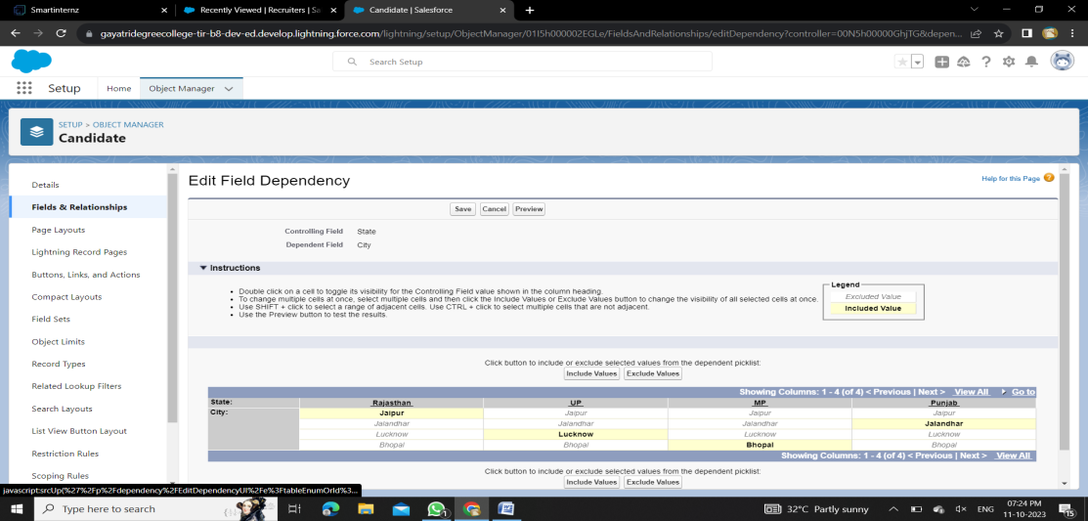

**Creation Lookup Relationship For The Job Application Objects**

Let’s create two lookup relationship on job application object First lookup relationship

From Setup, go to Object Manager

On the sidebar, click Fields & Relationships.

Select Lookup relationship & click next

Choose the related object as Candidate & click next

Give the field label(Candidate name) & click next, next, next and Save

Second lookup relationship

From Setup, go to Object Manager

On the sidebar, click Fields & Relationships.

Select Lookup relationship & click next

Choose the related object as Job & click next

Give the field label(Job Name) & click next, next, next and Save

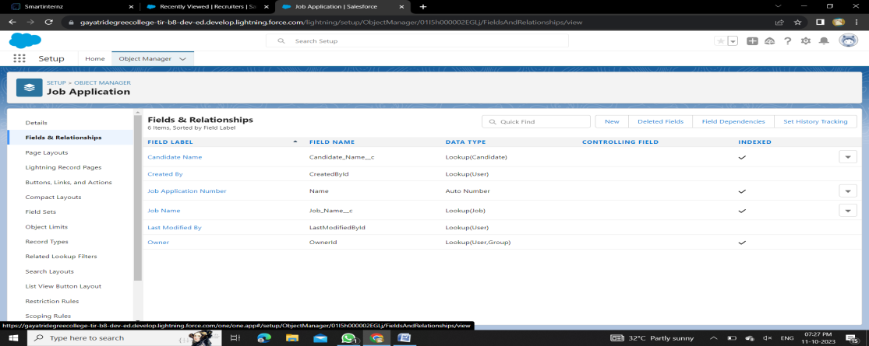

**Milestone – 6:**

**Profile**

**Create A Custom Profile**

1.From setup , enter profiles in Quick Find box

2.Select profiles (Standard user).

3.Click clone.

4.For Profile, enter Recruiter.

5.Click save.

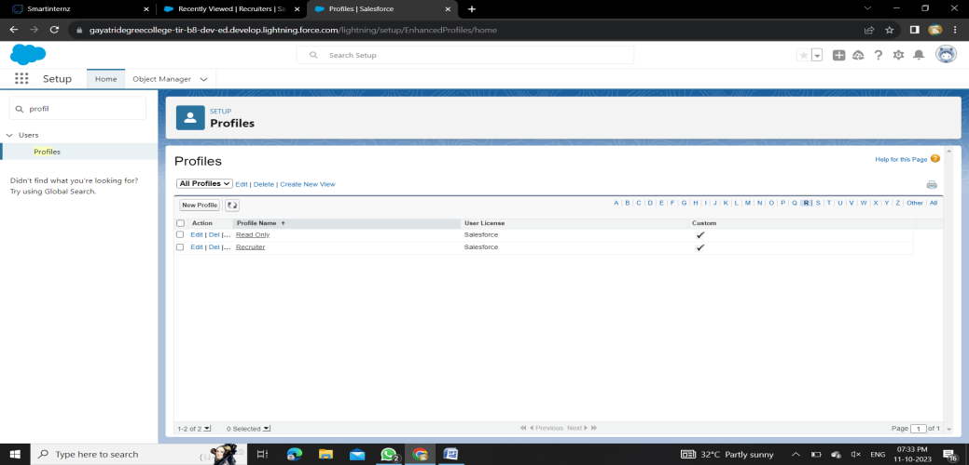

**Create A Custom Profile-2**

Create a profile with the profile name as “Sales Manager”.

1.From setup , enter profiles in Quick Find box

2.Select profiles (Standard user).

3.Click clone.

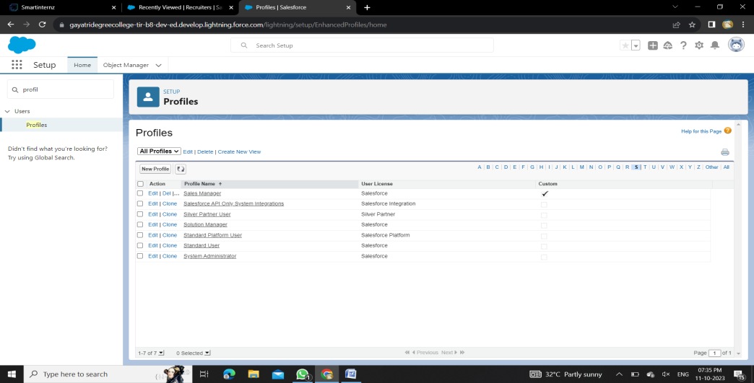

**Milestone – 7:**

**Role**

**Creation Of Role**

1.From the Quick find box search for the role and click on the roles option

2.select the set up roles option

3.Below the CEO click on add role and enter the label name as a ” HR Manager ” and role name will be Automatically populated and click on save.

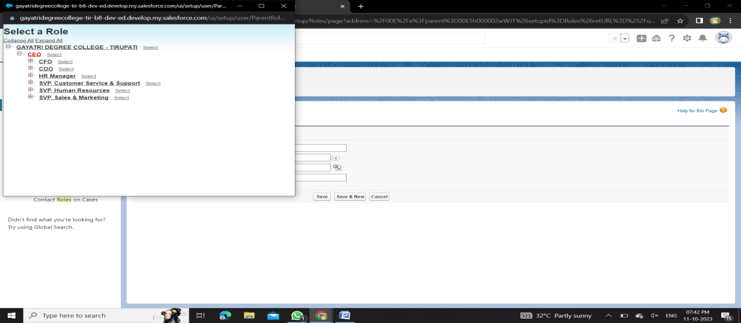

**Milestone – 8:**

**User**

**To Create A User**

1.From Setup, enter Users in the Quick Find box, then select Users.

2.Click New User.

3.Enter First name as HR and last name as Manager.

4.Enter the user’s name and email address and a unique username in the form of an email address. By default, the username is the same as the email address.

5.Then create a new role HR Manager.

6.Select user License as Standard Platform User.

7.Select profile(Recruiter).

8.Click save

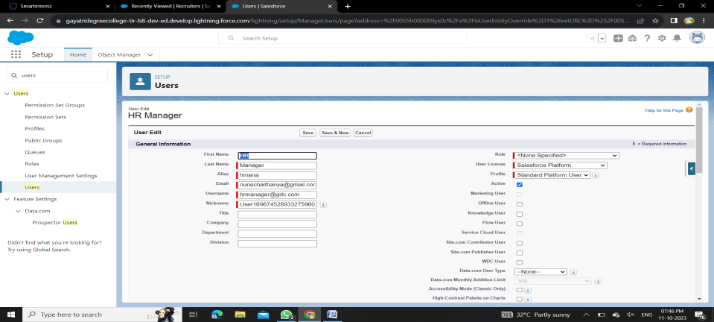

**Create Another User**

Create a user with a username as “Ganesh Gelli”, and assign him the sales Manager profile. Follow the steps from above Activity

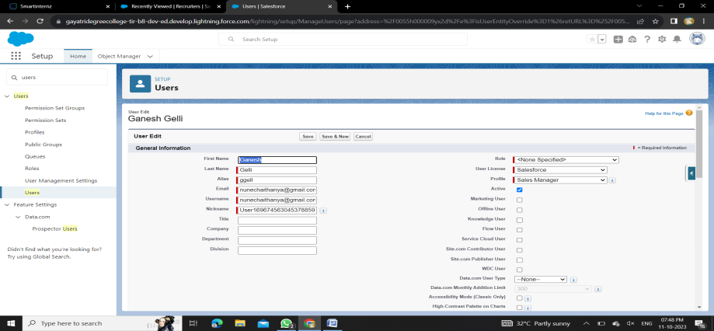

**Milestone – 9:**

**Sharing Rules**

1.Go to Sharing Settings, which can be found under the Quick Find section.

2.Scroll down and find the candidate object where a sharing rule needs to be added, and then click on New to create a new sharing rule.

3.Add the label of the sharing rule you want to make.

4.Select your rule type based on the criteria.

5.Select the field can join immediately check field from the candidate object.

6.Select the State as equal and value is Rajasthan.

7.And in selecting the users to share with the section select roles and in that select Hr Manager.

8.And in the section of select the level of access for the users give the access Read/Write.

9.And save the rule.

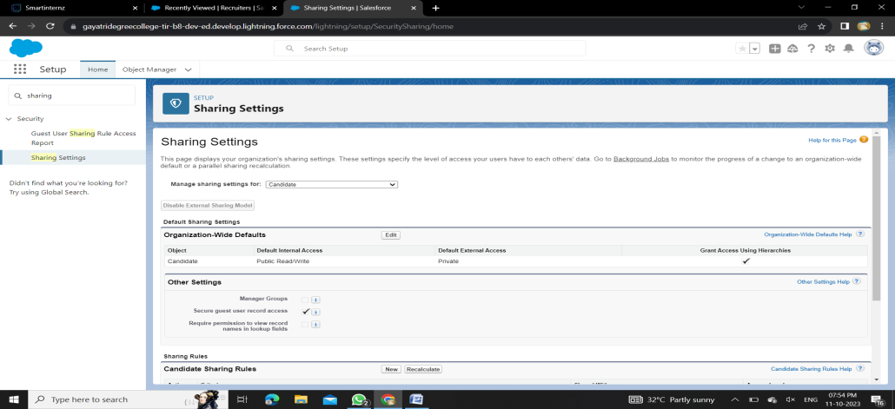

**Another Sharing Rule**

Create a Sharing Rule to Share the records of Job Application to Hr Manager with the Access of Read/Write.

Follow the steps from above Activity.

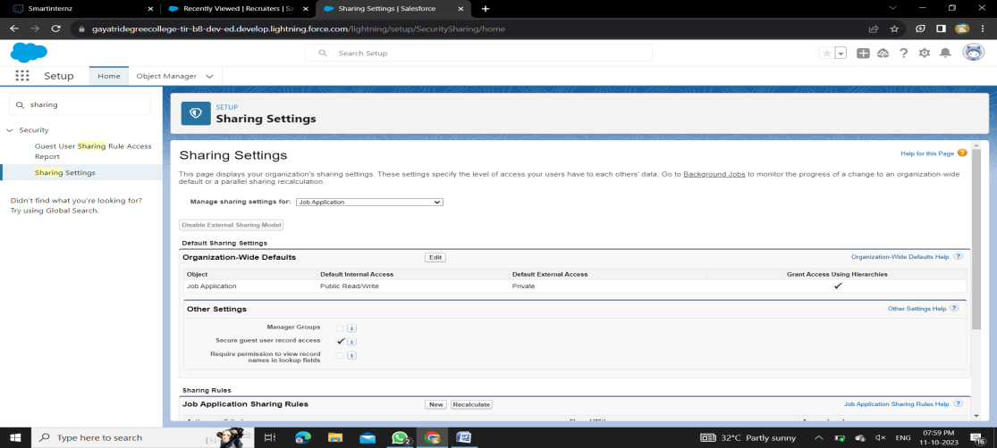

**Milestone – 9:**

**User Adoption**

**Create A Record(Recruiter)**

* Click on App Launcher on left side of screen.
* Search Job Application Tracking & click on it.
* Click on Recruiter Tab.
* Click new and fill details & Save

**View A Record(Recruiter)**

* Click on App Launcher on left side of screen.
* Search Job Application Tracking & click on it.
* Click on Recruiter Tab.
* Click on any record name. you can see the details of the Event.

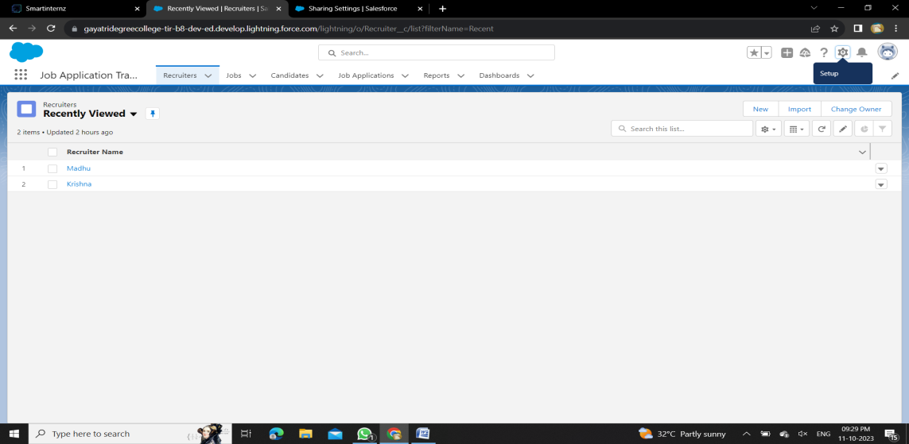

**Delete A Record(Recruiter)**

* Click on App Launcher on left side of screen.
* Search Job Application Tracking & click on it.
* Click on Recruiter Tab.
* Click on Arrow at right hand side on that Particular record.
* Click delete and delete again.

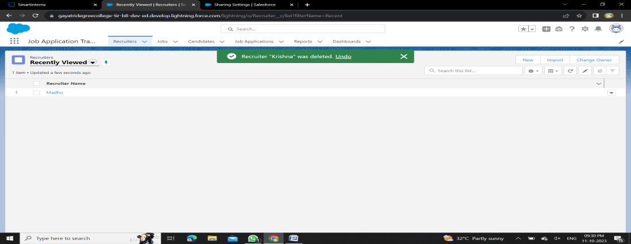

**Milestone 11:**

**Reports**

**Create A Report**

Create a report that displays rating of the account and which has type and account name.

1.Click on app launcher search for reports.

2.Click on the new report and select the category has job application with candidate name.

3.In the details section select the option start report.

4.show me my job application and job application created date(All time)

5.In the outline pane, group rows select job application created date.

6.Save the report by giving label name(Job application wtih candidate name) and save the folder as a public folder and save the report

**Create Another Report**

Create a Report using the Objects Jobs, Candidate and Job Application. Follow the steps from above Activity.

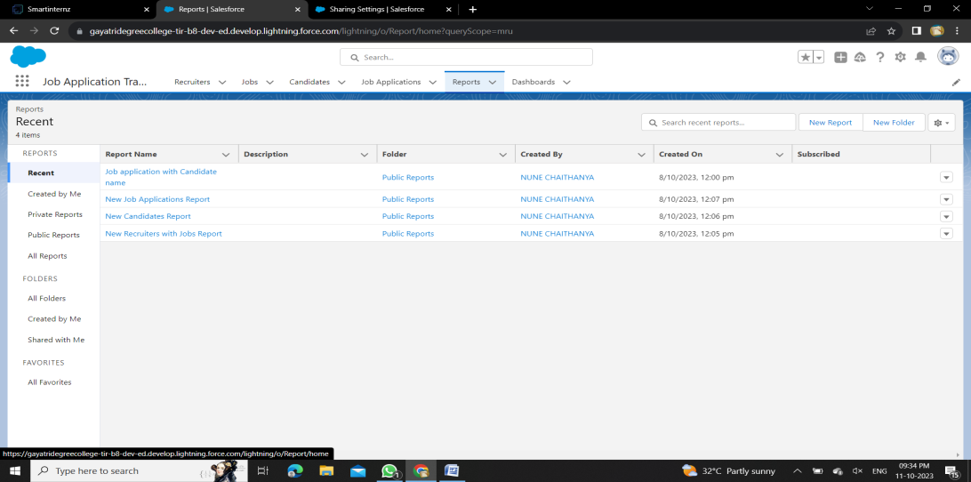

**Milestone 12**

**Dashboard**

**Create A Dashboard**

1. Click the Dashboards tab.
2. Click New Dashboard.
3. Name the dashboard Job application wtih candidate name and click Create.
4. Click +Component.
5. Select the Job application wtih candidate name and click Select.
6. Select the Gauge chart and click Add.
7. Click Save and then Done.

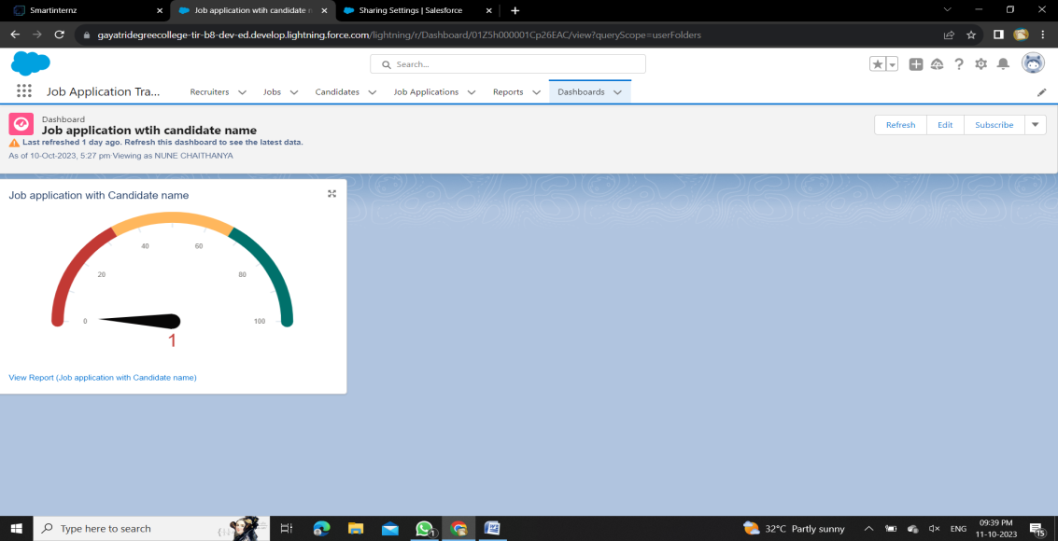

**Milestone – 13**

**View Report And Dashboard**

**Report**

* Click on App Launcher on left side of screen.
* Search Job Application & click on it.
* Click on Reports Tab.
* Click on job application wtih candidate name & see records

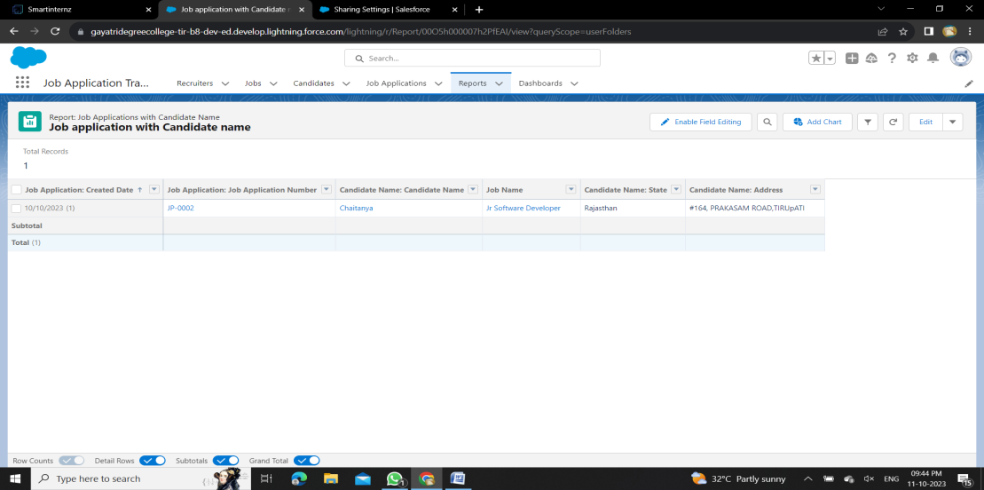

**Dashboard**

* Click on App Launcher on left side of screen.
* Search job application & click on it.
* Click on Dashboard Tab.
* Click on job application wtih candidate name & see records

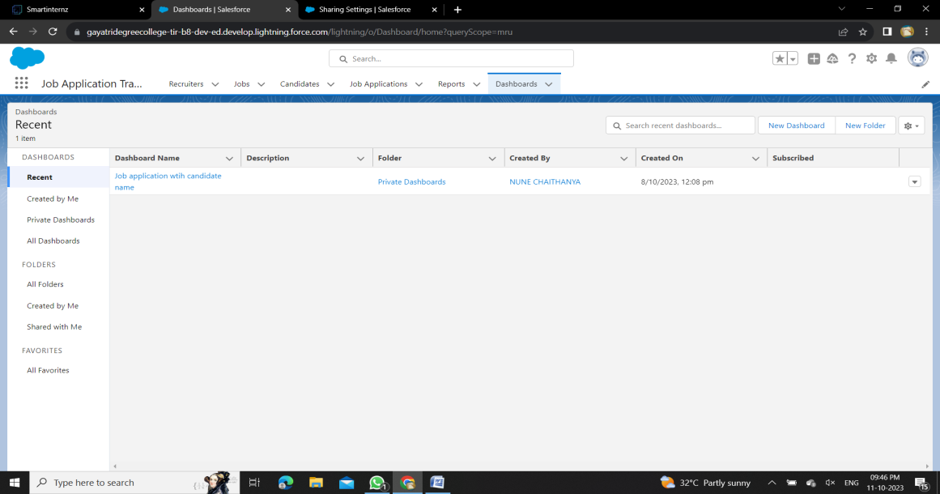

**Milestone – 14:**

**Flows**

**Create A Record Trigger Flow On Job Object**

1. Click on Gear icon and select setup
2. In Quick find Box enter flow and select the flows
3. Click on New flow and Select Record triggered Flows.
4. In the search bar type job and click done.
5. Add an element called Get record .
6. Label name as Recruiter Records.
7. Select the object as Recruiter.
8. After entering the object follow the steps .
9. Conditional requirements should be all conditions are met ( AND ).
10. Select the field as Recruiter_Email__c.
11. Operation should be Is Null .
12. Value should be False. And click done.

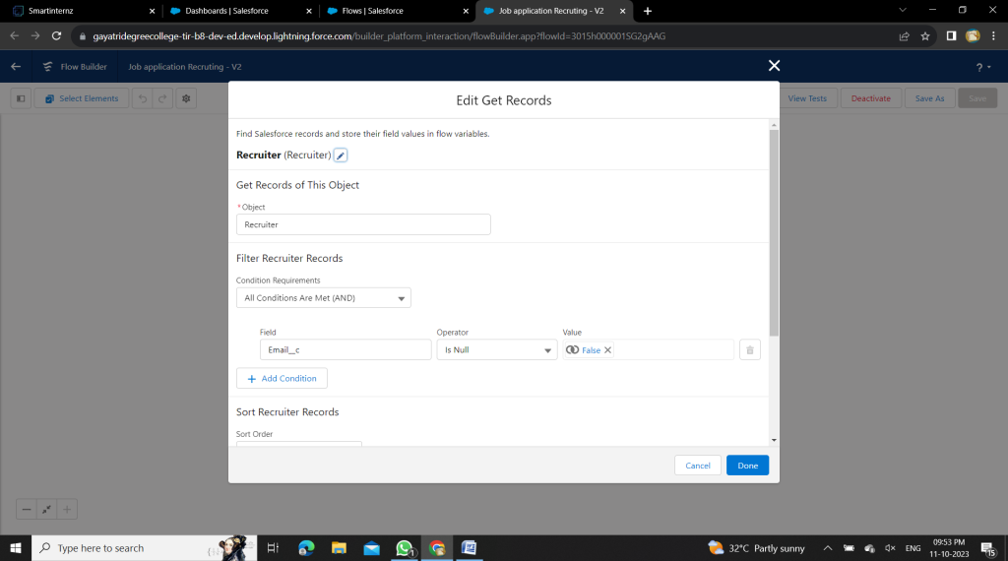

1. Add another element called Action.
2. Click on the Action and start creating new action .
3. Select the action as Send Email .
4. Enter the label name job email, API name is auto populated .
5. Set input values as
   1. a. Body : {!$Record.Name} with {!$Record.Job_Application_Id__c} is available. Please find the suitable candidates for the position.
   2. Subject : {!$Record.Name}
6. Recipient Email Addresses (comma-separated) should be included for that turn it on.
7. Recipient Email Addresses : {!$Record.Recruiter_Name__r.Recruiter_Email__c}

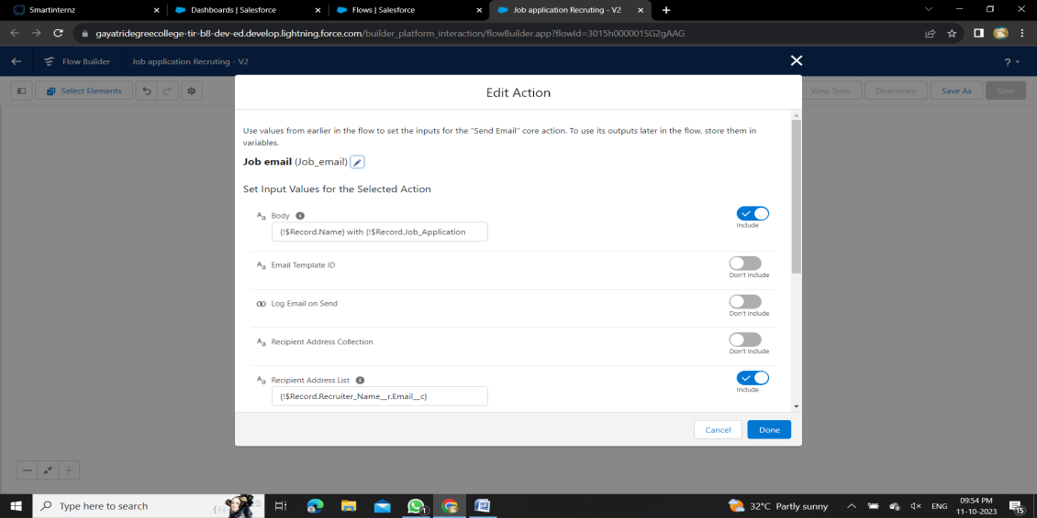

20.Click on done .After the completion of flow, check whether the flow is running and click save and Activate the flow .

**Create Another Flow**

1. Click on Gear icon and select setup
2. In Quick find Box enter flow and select the flows
3. Click on New flow and Select Screen Flows.
4. Add an element called screen .
5. Screen label should be Candidate details.
6. API name is auto populated.
7. Add the components in canvas .
8. Select the text from the components .
9. Label name as Candidate name.
10. API name is auto populated.
11. Select the text area from the components.
12. Label name as Address.
13. API name is auto populated.
14. Select the email from the components.
15. Label name as Email.
16. API name is auto populated.
17. Select the Phone from the components.
18. Label name as Phone.
19. API name is auto populated.
20. Select the picklist from the components.
21. Label name as Education.
22. API name is auto populated.
23. And select the choice as {!pick}.
24. Add a header to the canvas candidate flow for job application .
25. Click on save.

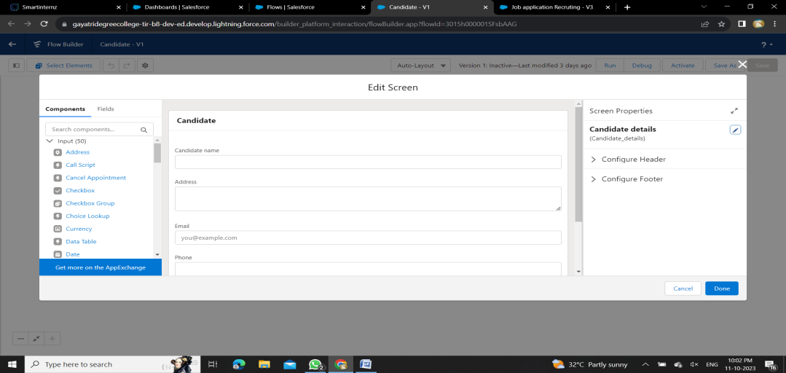

1. Next , add another element called create record .
2. Label name should be Create candidate record.
3. API is auto populated . and change the How to Set the Record Fields to Use separate resources, and literal values.
4. Select the object Candidate1.
5. Set the values for the candidate1 as
6. Field is Address__c and value should be {!Address}.
7. Field is Education__c and value should be {!Education}.
8. Field is Email__c and value should be {!Email.value}.
9. Field is Name and value should be {!Candidate_name}.
10. After that click on done.

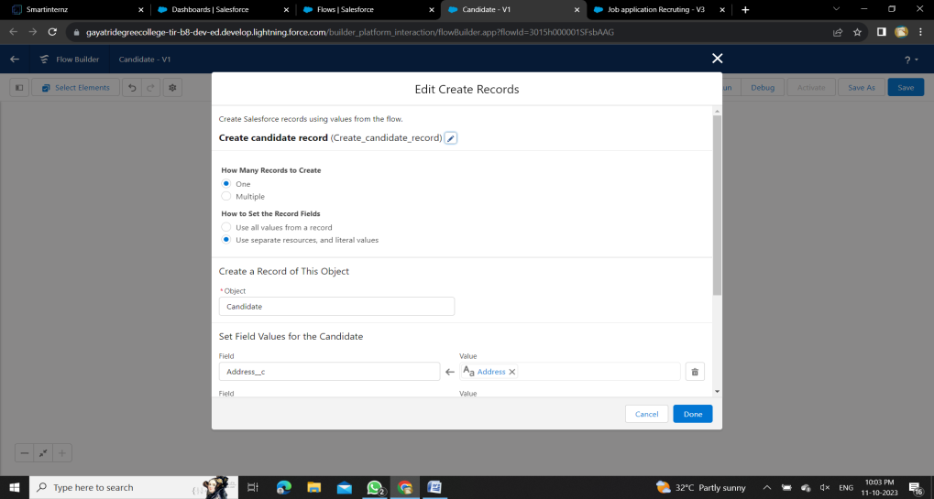

1. Run the flow and check whether the flow is working and click on save.
2. And activate the flow.

**THE END**